Zachary Weiss

ME570 HW4

Professor Tron

17 November 2020

*Q2.1*:

Discretization was too course, well-tuned, and too fine, at an NCells of 8, 20, and 200 respectively. Their graphs are as follow:

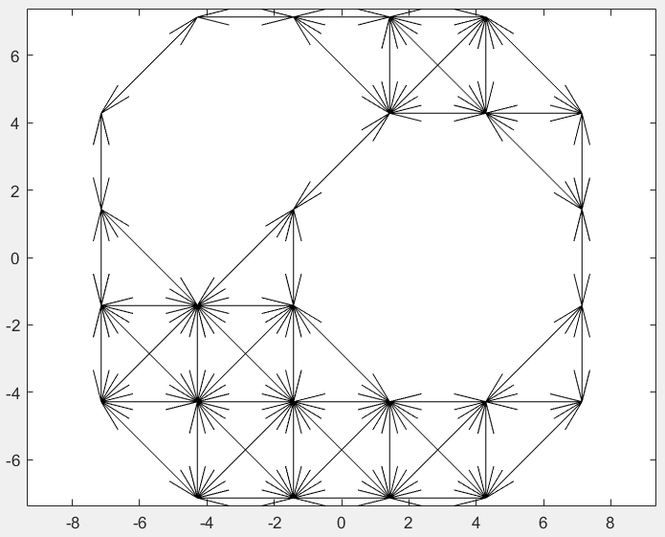

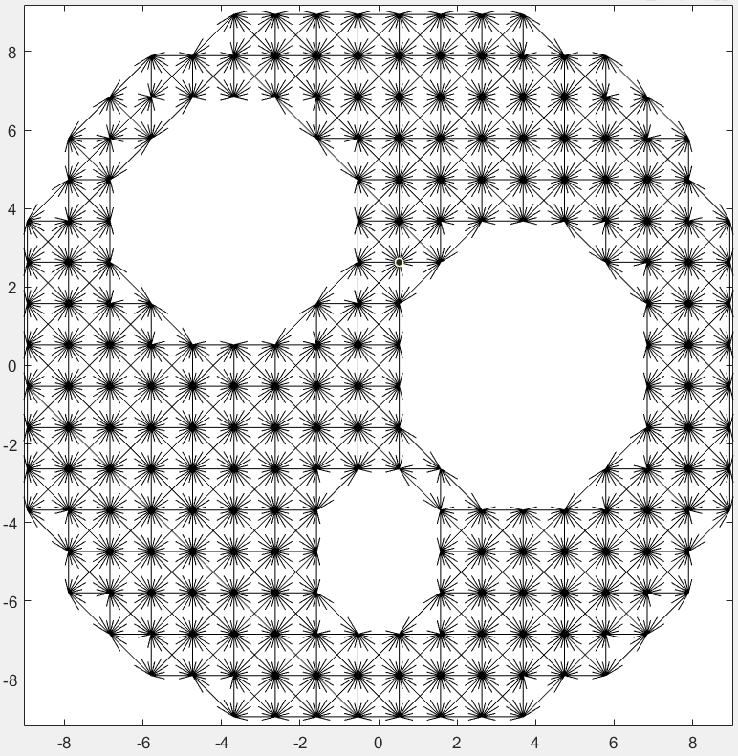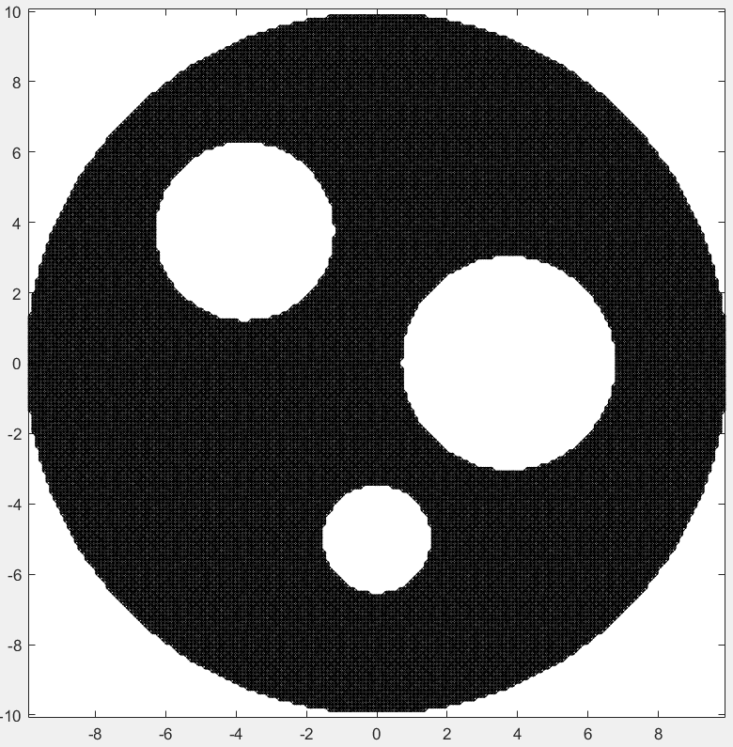

*Q2.2*:

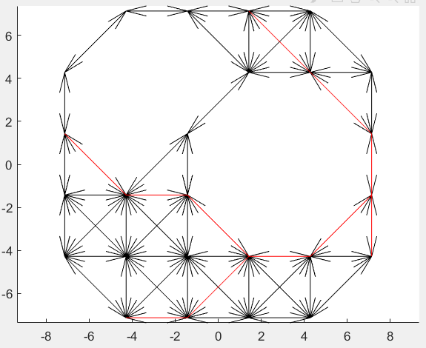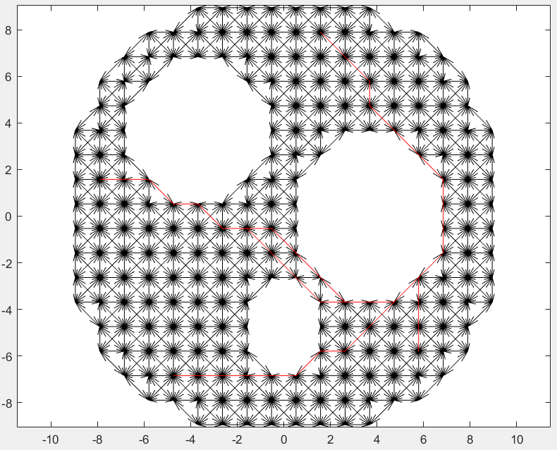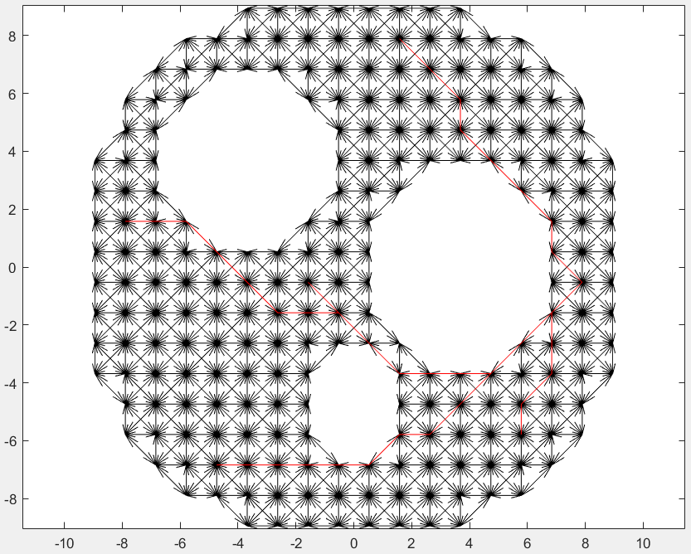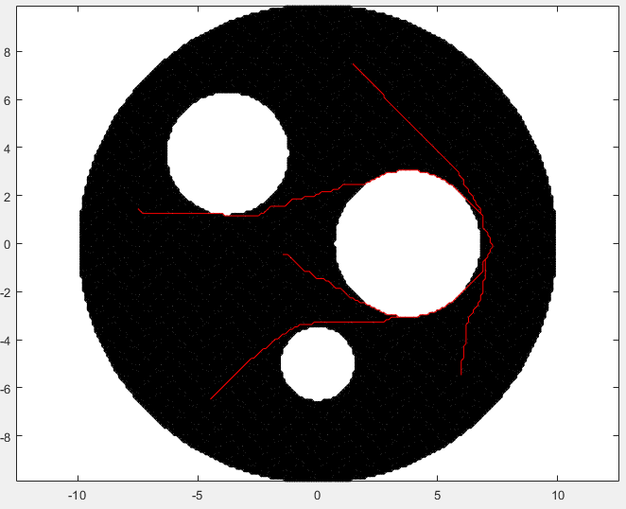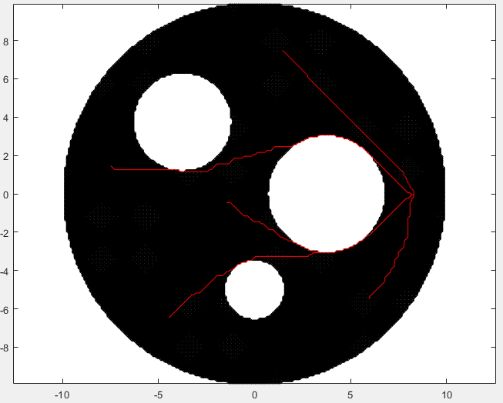

*Q2.3*:

In instances with too few cells, there isn’t sufficient granularity to distinguish the goals, and as such both plots appear the same. In the ‘just right’ number of cells, starts and goals are sufficiently distinguished, and paths are refined to slightly more optimal / shorter routes. In the overly-fine cell count, paths are smoother (and one path finds a shorter route going above the largest obstacle rather than below, indicating the ‘just right’ cell count could possibly be slightly higher for more optimal planning), but computation takes much longer.

*Q2.4*:

A\* finds similar paths to the potential planner, but due to discretization appears more rough / unnatural. It additionally has different behavior by obstacles, approaching as close as the grid granularity allows, whereas the potential planner keeps a distance away, proportional to the repulsive weight set. With A\*, there is no practical considerations beyond perhaps cell count between the two goal locations, whereas with the potential planner one must ensure the repulsive weight and potential shape are conducive to global convergence to the goal (the one within the radius of influence of an obstacle may become unreachable if one is not careful, and similarly, one must worry about local minima that are not the goal).

*Q3.1*:

The freespace of the twolink is represented below (bounds are from zero to 2pi along both axes, maps to torus).

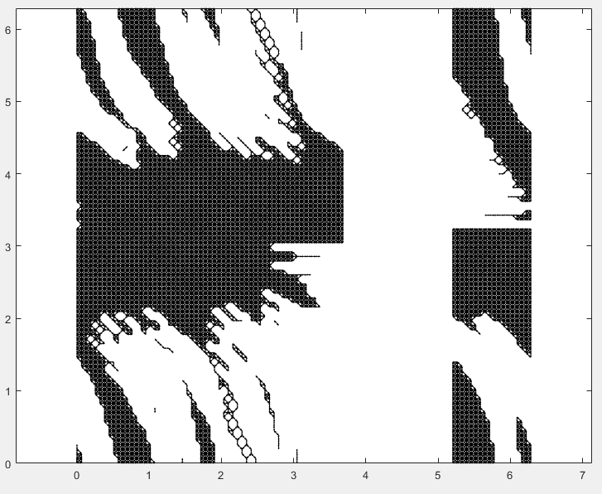

*Q3.2*:

Q3.3

Q3.4